Design desk stand  Everywhere information has to be in a prominent position… desks, counters, offices, receptions, lobbies, waiting rooms.  Product description:  - 10 pockets available in grey and blue.  - 1 wall unit, 1 base, 1 left foot and 1 right foot in grey.  - 5 index tabs for 10 pockets.  - Can extend to 20 and 30 pockets with the addition of wall kits (Art.71430x).  - Infinitely extendable with extension kits (Art.73435x).  - Assembly instructions included.  Unique selling points:  - Practical and stable design.  - Simple to set up : no assembly tools required.  - A multifunctional base turned forward, which provides space on the desk to store objects.  Usage:  - Development of specific promotions, evacuation plans, work procedures, phone lists, etc.  - Reception halls, corridors, offices, etc.  Technical characteristics:  - Polypropylene pockets.  - Polysterene stand.  Packaging:  - 1 kit per printed box. | 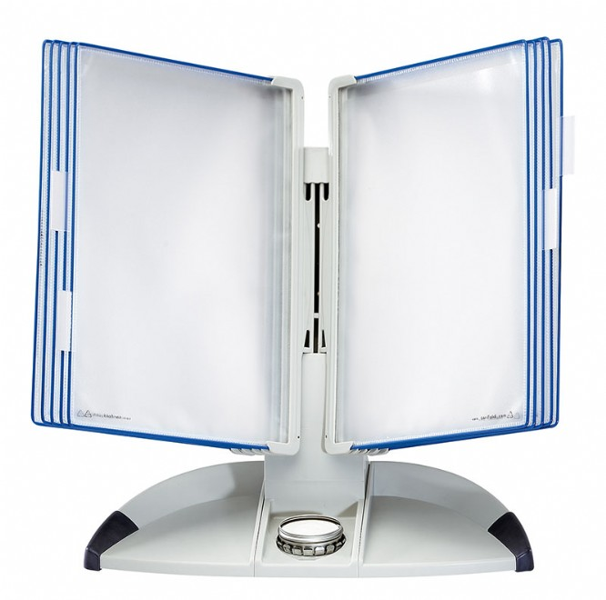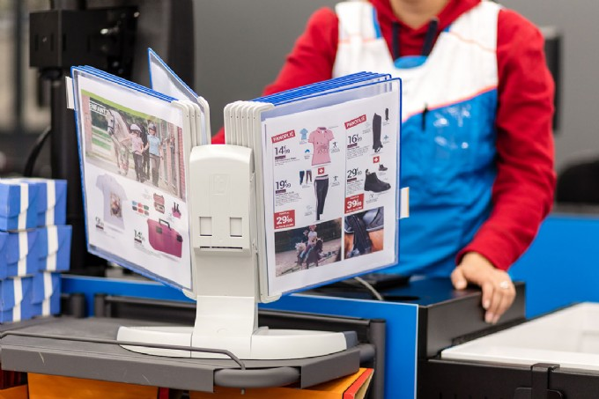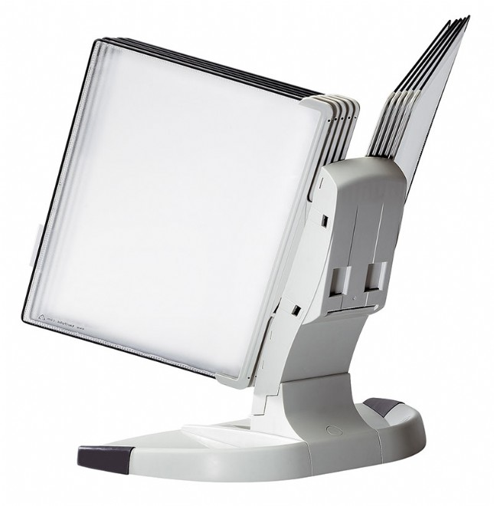

Article | Description | Size of product | Nbr of pcs per sales unit | MOQ
704301 | Pockets - blue | 255x355 mm | 10 | 1

Article | Sales unit - Weight/EAN Code | Display Box - Qty./Weight/EAN Code | Export Box - Qty./Weight/EAN Code
704301 | 450 g / EAN 3377997043011 | 10 / 9550 g / EAN 3377990008857 | n/a / n/a g / EAN n/a

Custom Code: 392 61 000 000 OD

